Overview
In our assignment, we need to make a full stack application named SavePlate which is a smart food reduction application. It helps the people of Malaysia to manage their food and control wastage. Our application is a web based which is made to solve the problem of food wastage created by the excess food consumed by the people. This is done by allowing users of our web app to track their food intake, provide notification as per their choice about the tasks that they need to do and also reminders to track the expiry date of foods, planning of the meal and many other features.
Motivation for this project
The problem of food is a major issue as it can affect human health and cause environmental harm. The wastage produced from the households can create problems for maintaining them properly. Since this is a huge issue and it needs to be resolved we wanted to create a platform that could help in minimizing the wastage production from the household. We also wanted an application where the normal citizens could login based on their national identification number and they could view the result of the residents of Malaysia in real time, and also perform activities like tracking and updating of inventories, meal planning options, showing progress level and such.
Customers/Users
For our application, the primary customer/user are the households that regularly purchase foods and prepare in large amount. Students, Teachers, Government, normal residents who want a system to make the management of food and wastage are also the customers of our application. Everyone who wants to use the application are the customers of our application.
Project Deliverables
SavePlate is a web based application that offers the users of our application the following:
- Users can login and signup using their national identification number. They are offered full privacy and support for Two Factor Authentication (2FA).
- Food Inventory Management as per their choice. They can also track the expiry date of the food.
- Notification system for expiry alerts, donations, and meal reminders.
- Donation option for excess food and also able to view the listings of food added by other users.

Product Type
SavePlate is a web based application that is accessible to all the residents of Malaysia. It is a new product which we are going to build from the start. For developing this project we will be using the following technologies:
- React JS
- Node JS and Express JS
- MongoDB
For the development of the frontend part, we will use React JS, for Backend we will use Node JS and Express JS and for the database we will use MongoDB which stores data in unstructured way.
Cost and Duration
The scale of the product is really large. But for this assignment we will work on the specified use cases and for that we would need the time starting from 18 May, 2026 to 20 June, 2026. The development, design and testing of the application will done by our team. Since it is an assignment and there are no involvement from outside developers or team there will be no direct costs and for the database we will use the free version for this assignment. Later on the future, it could be converted where the cost can rise and be mentioned.

Project Aims
The aims of our project are written below:
- To develop a user friendly and a centric platform for all the residents of Malaysia which helps them to reduce the food wastage.
- To allow residents to share food by listing in the platform and also enabling options for them to donate food and also other residents to browse and claim the items they need.
- To provide analytics by showing the data of food consumption waste made in a graph to help them to make better food wastage choices.
- To deliver residents a secure application that protects its conusmers privacy and account integrity with the help of two factor authentication.
- To apply the iterative development practices to ensure the application is built, tested, and maintained properly.
Project Objectives
The objectives of our project are written below:
- Implement a secure user registration and authentication that supports 2FA and also allows users to configure account privacy settings.
- Develop a food inventory that enables residents to add, edit, and delete food items that they want to add with their attributes like name, quantity, category, expiry date, and storage location.
- Build a donation management system that allows residents to list the excess foods in the donation listing and notifies people about the new donation item.
- Integrate a food analytics dashboard that shows the visual representation of the food saved and donation made along with comparison chart on the basis of time.
- Implement a notification system that delivers real time notifications about the food expiry, donation confirmations, and other.

Project Scope
In Scope
The following features and functionalities will be available in this project:
- Register Users and Privacy Settings
The users of our web application can register their self, they can set up 2FA, receive email verification.
- Manage Food Inventory
The users can add foods, view foods listed, can update the foods if they made the wrong entry for the food, and also delete the food item.
- Browse Food Items
In our application the users who donates the food have separate listing and the users who wants donations have separate browsing listing. They can filter the donation type and find the donation that they require.
- Food Analytics
In our web application, the users have their own personal visual charts that shows them their progress and the comparison of foods saved, donated and wasted.
- View Notifications
The users are notified about the expiration date of food, donation listings, reminders about meal plans and events as set by the users.
- Plan Weekly Meals
The users can create their meal plans and also link to inventory items and also they can be reminded about the plans.
Out Scope
The following features are not currently available in the web application but we will be sure to add it in the future to make the web application better and easier to use for the residents while ensuring the necessary requirements of the residents are fulfilled.
- Integration with third part food vendors and delivery service providers to make the food purchase online easier and faster.
- Payment and subscription features.
- AI powered suggestions provider about the nutritional requirement and analysis, calorie counting, or health tracking system.

Project Schedule
Work Breakdown Structure – Tree Structure
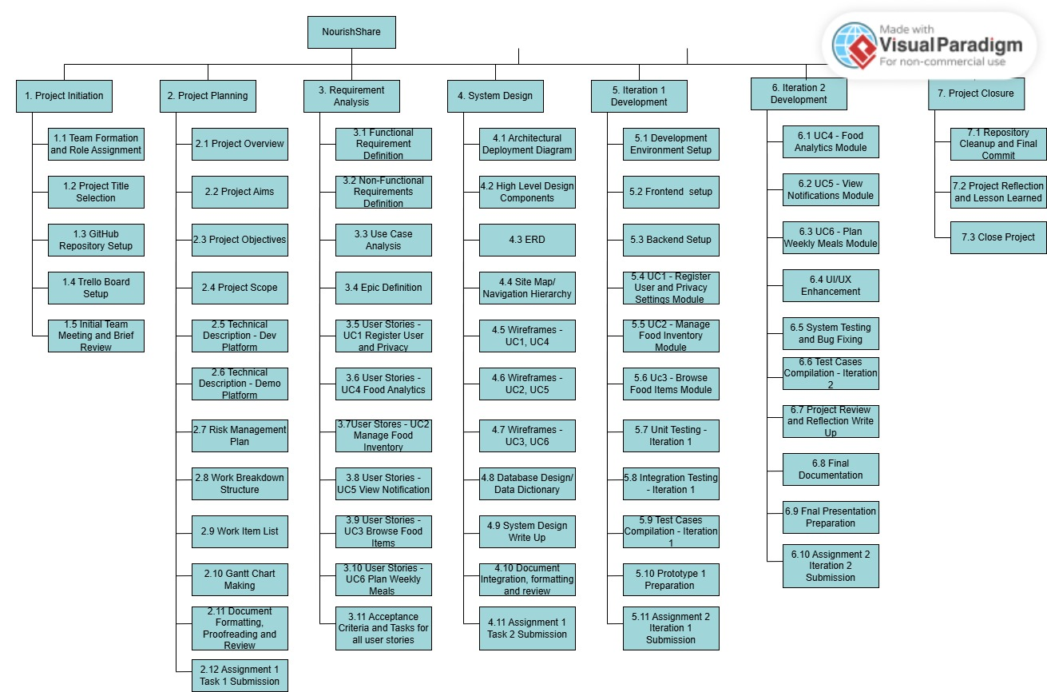

Work Item List
ID | Task Name | Assigned To | Effort (hrs) | Predecessor | Start | End | Milestone
1. PROJECT INITIATION
1.1 | Team Formation & Role Assignment | All | 2 | - | 18 May | 18 May
1.2 | Project Title Selection | All | 1 | 1.1 | 19 May | 20 May
1.3 | GitHub Repository Setup | Ghan Shyam Shrestha | 2 | 1.2 | 21 May | 26 May
1.4 | Trello Board Setup | Ghan Shyam Shrestha | 1 | - | 21 May | 23 May
1.5 | Initial Team Meeting & Brief Review | All | 2 | 1.1 | 18 May | 19 May | M1 – Kickoff
2. PROJECT PLANNING
2.1 | Project Overview | All | 3 | 1.5 | 20 May | 20 May
2.2 | Project Aims | All | 2 | 2.1 | 21 May | 21 May
2.3 | Project Objectives | All | 2 | 2.2 | 22 May | 22 May
2.4 | Project Scope | All | 2 | 2.3 | 23 May | 23 May
2.5 | Technical Description – Dev Platform | Ghan Shyam Shrestha | 3 | 2.4 | 24 May | 26 May
2.6 | Technical Description – Demo Platform | Ghan Shyam Shrestha | 2 | 2.5 | 27 May | 27 May
2.7 | Risk Management Plan | All | 3 | 2.4 | 24 May | 26 May
2.8 | Work Breakdown Structure | Ghan Shyam Shrestha | 4 | 2.4 | 27 May | 29 May
2.9 | Work Item List | Ghan Shyam Shrestha | 3 | 2.8 | 30 May | 30 May
2.10 | Gantt Chart (GanttProject) | Ghan Shyam Shrestha | 4 | 2.9 | 31 May | 02 Jun
2.11 | Formatting, Proofreading & Review | All | 4 | 2.6,2.7,2.10 | 03 Jun | 06 Jun
2.12 | Assignment 1 Task 1 Submission | Ghan Shyam Shrestha | 1 | 2.11 | 07 Jun | 12 Jun | M2 – Task 1 Due
3. REQUIREMENT ANALYSIS
3.1 | Functional Requirements | All | 4 | 2.12 | 13 Jun | 13 Jun
3.2 | Non-Functional Requirements | All | 2 | 3.1 | 14 Jun | 14 Jun
3.3 | Use Case Analysis | All | 3 | 3.2 | 15 Jun | 15 Jun
3.4 | Epic Definition | All | 2 | 3.3 | 16 Jun | 17 Jun
3.5 | User Stories – UC1 (Ghan Shyam Shrestha) | Ghan Shyam Shrestha | 5 | 3.4 | 18 Jun | 19 Jun
3.6 | User Stories – UC4 (Ghan Shyam Shrestha) | Ghan Shyam Shrestha | 5 | 3.4 | 18 Jun | 19 Jun
3.7 | User Stories – UC2 (Susmita Shrestha) | Susmita Shrestha | 5 | 3.4 | 18 Jun | 19 Jun
3.8 | User Stories – UC5 (Susmita Shrestha) | Susmita Shrestha | 5 | 3.4 | 18 Jun | 19 Jun
3.9 | User Stories – UC3 (Rupesh) | Rupesh  Thapa | 5 | 3.4 | 18 Jun | 19 Jun
3.10 | User Stories – UC6 (Rupesh) | Rupesh  Thapa | 5 | 3.4 | 18 Jun | 19 Jun
3.11 | Acceptance Criteria & Tasks | All | 6 | 3.5,3.6,3.7,3.8,3.9,3.10 | 20 Jun | 20 Jun
4. SYSTEM DESIGN
4.1 | Architectural Deployment Diagram | All | 3 | 3.11 | 21 Jun | 21 Jun
4.2 | High-Level Design Components | All | 2 | 4.1 | 22 Jun | 22 Jun
4.3 | ERD – Conceptual Data Model | Susmita Shrestha | 4 | 4.1 | 22 Jun | 22 Jun
4.4 | Site Map / Navigation Hierarchy | Rupesh | 3 | 4.1 | 22 Jun | 22 Jun
4.5 | Wireframes – UC1, UC4 (Ghan Shyam Shrestha) | Ghan Shyam Shrestha | 5 | 4.2 | 23 Jun | 24 Jun
4.6 | Wireframes – UC2, UC5 | Susmita Shrestha | 5 | 4.2 | 23 Jun | 24 Jun
4.7 | Wireframes – UC3, UC6 (Rupesh Thapa) | Rupesh  Thapa | 5 | 4.2 | 23 Jun | 24 Jun
4.8 | Database Design / Data Dictionary | All | 4 | 4.3 | 24 Jun | 24 Jun
4.9 | System Design Write-up | All | 3 | 4.8 | 24 Jun | 24 Jun
4.10 | Document Integration, Formatting & Review | All | 4 | 4.5,4.6,4.7,4.9 | 25 Jun | 25 Jun
4.11 | Assignment 1 Task 2 Submission | Ghan Shyam Shrestha | 1 | 4.10 | 26 Jun | 26 Jun | M3 – Task 2 Due
5. ITERATION 1 DEVELOPMENT
5.1 | Development Environment Setup | All | 4 | 4.11 | 28 Jun | 30 Jun
5.2 | Frontend Foundation (React) | All | 8 | 5.1 | 28 Jun | 30 Jul
5.3 | Backend Foundation (Node.js + MongoDB) | All | 8 | 5.1 | 28 Jun | 30 Jun
5.4 | UC1 – Register User & Privacy Module (Ghan Shyam Shrestha) | Ghan Shyam Shrestha | 16 | 5.2,5.3 | 01 Jul | 08 Jul
5.5 | UC2 – Manage Food Inventory Module (Susmita Shrestha) | Susmita Shrestha | 16 | 5.2,5.3 | 01 Jul | 08 Jul
5.6 | UC3 – Browse Food Items Module (Rupesh) | Rupesh  Thapa | 16 | 5.2,5.3 | 01 Jul | 07 Jul
5.7 | Unit Testing – Iteration 1 | All | 6 | 5.4,5.5,5.6 | 09 Jul | 11 Jul
5.8 | Integration Testing – Iteration 1 | All | 4 | 5.7 | 12 Jul | 14 Jul
5.9 | Test Cases Compilation – Iteration 1 | All | 4 | 5.8 | 15 Jul | 16 Jul
5.10 | Prototype 1 Prep & Presentation Slides | All | 6 | 5.9 | 17 Jul | 19 Jul
5.11 | Iteration 1 Submission & Presentation | All | 2 | 5.10 | 20 Jul | 24 Jul | M4 – Iteration 1 Due
6. ITERATION 2 DEVELOPMENT
6.1 | UC4 – Food Analytics Module (Ghan Shyam Shrestha) | Ghan Shyam Shrestha | 16 | 5.11 | 25 Jul | 02 Aug
6.2 | UC5 – View Notifications Module (Susmita Shrestha) | Susmita Shrestha | 16 | 5.11 | 25 Jul | 02 Aug
6.3 | UC6 – Plan Weekly Meals Module (Rupesh) | Rupesh  Thapa | 16 | 5.11 | 25 Jul | 02 Aug
6.4 | UI/UX Enhancement | All | 8 | 6.1,6.2,6.3 | 03 Aug | 04 Aug
6.5 | System Testing & Bug Fixing | All | 8 | 6.4 | 05 Aug | 08 Aug
6.6 | Test Cases Compilation – Iteration 2 | All | 4 | 6.5 | 09 Aug | 10 Aug
6.7 | Project Review & Reflection Write-up | All | 4 | 6.6 | 11 Aug | 13 Aug
6.8 | Final Documentation | All | 6 | 6.7 | 14 Aug | 16 Aug
6.9 | Final Presentation Preparation | All | 4 | 6.8 | 17 Aug | 18 Aug
6.10 | Iteration 2 Submission & Presentation | All | 2 | 6.9 | 19 Aug | 21 Aug | M5 – Iteration 2 Due
7. PROJECT CLOSURE
7.1 | Repository Cleanup & Final Commit | All | 2 | 6.10 | 22 Aug | 22 Aug
7.3 | Archive & Close Project | All | 1 | 7.2 | 22 Aug | 22 Aug | M6 – Closed

Technical Description of the proposed system
For our web application, we discussed about what could be the best and well known technologies to develop the application. We first discussed how the applications can be made and then chose the tech stack as per the familiarity of all members. We also chose the required tools, languages and frameworks for completing this project.
Development Platform
Criteria | Tools/Hardware | Version | Description
Documentation | MS Word 2016 | 2016 | We used MS to write the whole project documentation, reports and the deliverables.
Modeling -Requirement | Draw.io | Web | We used it to create the diagrams for the application like entity relationship diagrams and others.
Modelling - Design | Figma | Web | Figma was used to create the wireframes for the web application.
Project Management | Trello | Web | We used Kanban boards to manage sprint tasks, assign ownership and track progress.
Collaboration | Git/Github | 2.51.1.windows.1 | We used git for version control and GitHub for creating repository and sharing documents and collaborating too.
Framework -Frond End | React Js | 19+ | It is a library of Javascript which is component based and we used it to make the work easier faster and single page application.
Framework - Backend | Node Js + Express Js | 22.21.0 | For making the server side processing and REST API.
Database | MongoDB | 8.3 | For storing the data that the users enters in the web application in a NoSQL document format.
Hardware (Notebook Spec) | Core i3,i5, 8 GB RAM, 256 GB SSD, 512 GB SSD, Windows 10 and 11

Demonstration Platform
Criteria | Tools/Hardware | Version | Description
Browser | Google Chrome | Latest | This browser is for live demonstration and for the checking of the work progress during development and assessment.
Hosting | Vercel/Localhost | - | The web application can be shown in the local host in the users browser and to make it publicly accessible vercel is used. Vercel is an web application hosting platform where the developers can host their website for free.

Risk Management Plan
Risk Name | Description | Probability | Mitigation
Scope Creep | This is when the group members add unplanned features during the development phase which increases the time length for production. | M | Before starting the development phase, strictly telling each members that we will only follow the discussed use cases and develop only those.
Team Member Unavailability | This is when a group member is suddenly unavailable for work due to reasons like illness, academic or personal issues. | M | Allocating the group member task among the remaining group member as soon as possible.
Technical Difficulty | Our group might encounter certain needs that we find difficult like the MongoDB aggregation, JWT, OAuth, React Hooks and other. | H | Learning from official documentation and also asking peers for clarification regarding the topics.
Data Loss or File Corruption | Project files or the source code are deleted accidentally or is corrupted. | L | Maintaining the files and code in the GitHub and tracking the commits.

